Overview –
AHRQ Safety Program for MRSA and SSI Prevention

Slide Title and Commentary | Slide Number and Slide
Overview – AHRQ Safety Program for MRSA and SSI Prevention  SAY:  Hello! Welcome to this brief presentation to inform you about the upcoming AHRQ Safety Program for methicillin-resistant Staphylococcus aureus (MRSA) and surgical site infection (SSI) Prevention. This program is funded and guided by the Agency for Healthcare Research and Quality (AHRQ) and led by Johns Hopkins Medicine and NORC at the University of Chicago.  High-risk inpatient surgical services that conduct procedures with greater risk of MRSA invasive infection and SSI are eligible and encouraged to participate in the program. The targeted services and procedures will be shown later in this presentation.  This program is designed to provide technical assistance and support for MRSA and SSI prevention, and we hope that you will consider joining the project to reduce infections and protect your patients. | Slide 1  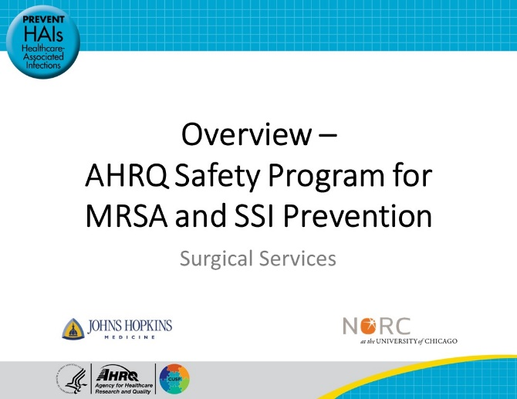
Presenters  SAY:  This slideshow is presented by the following three experts.  Glenn Whitman is a Professor of Surgery and the Director of the Cardiovascular Surgical Intensive Care Unit at Johns Hopkins Hospital.  Sara Karaba is an infectious diseases physician and assistant professor of medicine at the Johns Hopkins University School of Medicine.  Sean Berenholtz is a professor of anesthesiology and critical care medicine with the Johns Hopkins University School of Medicine.  Our presenters will be leading and presenting the content for this MRSA and SSI prevention program, along with colleagues at Johns Hopkins Medicine and NORC at the University of Chicago. We will provide a brief overview of the project today and then welcome your questions. The Safety Program’s email address is MRSAPrevention@norc.org. | Slide 2  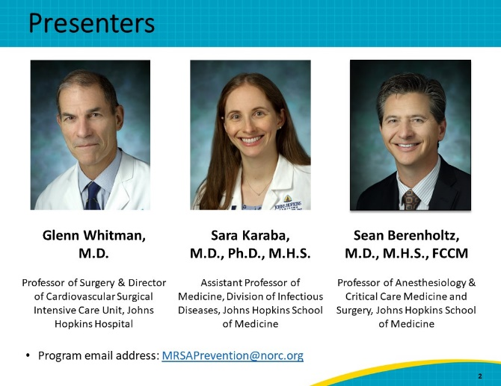
MRSA and Surgical Site Infections Are a Serious Threat  SAY:  Surgical site infections (SSIs) pose a risk for all surgical patients. Cases can range from superficial to life-threatening – causing significant morbidity and mortality. SSIs account for at least 20 percent of all healthcare-associated infections (HAIs), affecting 4 percent of hospitalized patients annually. They also contribute to increased length of hospital stay, increased readmission rates, cost, morbidity, and mortality.  SSIs represent one of the most common and most costly of all HAIs, estimated to account for nearly a million additional inpatient days and $3.3 billion in healthcare expenditures every year. Up to 60 percent of SSIs are estimated to be preventable, using existing evidence-based strategies and guidelines.  Staphylococcus aureus represents a particularly critical threat, as it is the leading causative organism of SSIs. According to NHSN data, Staph aureus is the most reported causative organism among SSIs overall at 17.5 percent. Staph aureus is also the most common pathogen for SSIs in orthopedic and cardiac procedures, causing 38.6% and 27.0% respectively. Studies have shown that SSIs caused by methicillin-resistant Staphylococcus aureus (MRSA) are associated with higher mortality rates, longer lengths of stay, and elevated costs of hospitalization compared with SSIs caused by other organisms. Therefore, reducing SSIs including those caused by MRSA is an important patient safety goal with the potential to dramatically improve patient outcomes.  We are seeking inpatient surgical services whose patients are at high risk for MRSA invasive infection and SSIs to enroll in this program. This is an opportunity to reduce MRSA and SSI infections in your facility and strengthen team-based infection prevention practices while fostering a culture of safety. We urge you to consider enrolling in the program. The cohort starts in January 2023, and the enrollment deadline is January 15, 2023.  If you enroll in January, we will help you get up to date with the program quickly. | Slide 3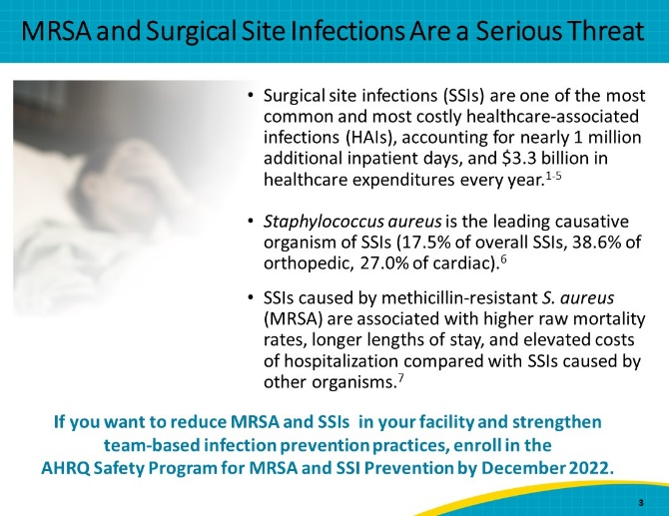
A Patient’s Story  SAY:  We just reviewed some statistics about the complications from SSIs, and these are sobering. It can also be helpful to understand the impact that this complication can have on friends and family. A member of our team, Dr. Glenn Whitman, had a close friend he had looked up to for much of his life. This friend was an internationally competitive athlete, who also ended up requiring bilateral hip replacements some 20 years ago. This in no way impeded his competitive spirit or his activities, and he would say to anybody who would listen how lucky he was to have lived at this time and to have benefited so dramatically from the advances of modern medicine. This past year at age 80 he needed and underwent a hip revision. Unfortunately, he died postoperatively of complications from a MRSA wound infection.  While this story illustrates the most severe complication from an SSI, death, we also know that SSIs can cause morbidity in many ways as well, such as loss of ambulation and independence, need for repeat surgical interventions, and many more. We wanted to share this patient story to illustrate how devastating an infection can be for the patient and for their loved ones. | Slide 4  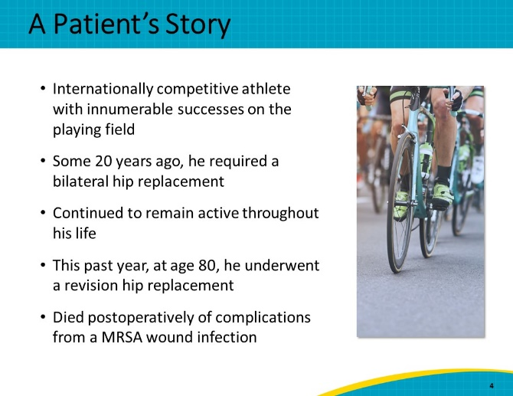
AHRQ Safety Program Overview  SAY:  The overarching goal of this collaboration is to prevent surgical site infections caused by MRSA and other organisms.  Two additional goals of the program are to strengthen the culture of safety and build capacity for team-based quality improvement activities, and to provide technical assistance for the implementation of evidence-based infection prevention practices that help prevent surgical site infections. | Slide 5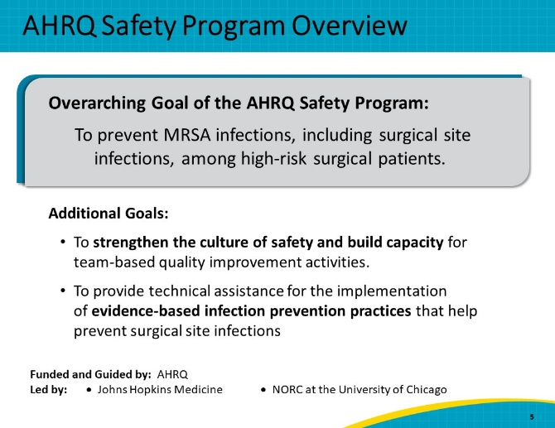
AHRQ Safety Program Approach  SAY:  The approach of the AHRQ Safety Program focuses on two major domains of infection prevention strategies: technical interventions and adaptive interventions.  The technical interventions for MRSA and SSI prevention focus on evidence-based best practices to interrupt transmission and infection. These include preoperative chlorhexidine gluconate (CHG) treatment, nasal decolonization treatment, appropriate antibacterial prophylaxis, and basic infection prevention measures such as hand hygiene,  Adaptive interventions focus on enhancing a culture of safety by changing behavior. This behavioral change will be guided by the Comprehensive Unit-based Safety Program or CUSP.  CUSP is a proven approach to improve both teamwork and safety culture. This program will help services establish and facilitate a CUSP team and will support those teams. The CUSP team will be the backbone of improvement efforts in participating services.  The goal – or the “sweet spot” – is at the center of this diagram, when technical and adaptive interventions overlap. Doing both is necessary for achieving desired outcomes and lasting change. | Slide 6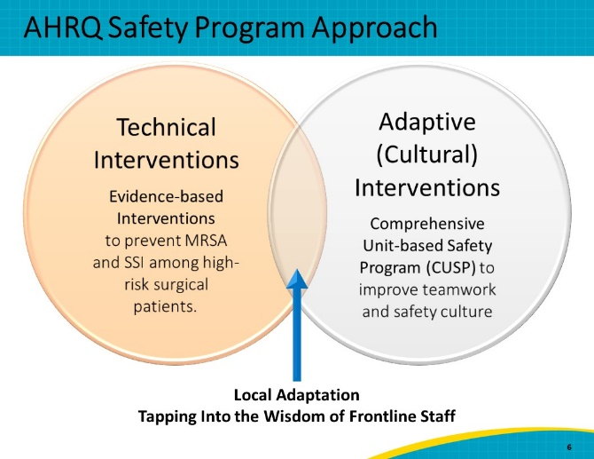
The Benefits of CUSP  SAY:  The overall goal of CUSP is to enhance the implementation of evidence-based interventions to reduce patient harm and improve the safety of healthcare. This often requires cultural change.  This program recognizes not only the importance of leadership, but that lasting change relies upon its partnership with frontline staff to own and to address the problems they see. The CUSP framework accomplishes this by emphasizing that patient harm is unacceptable and by recognizing that frontline staff have the wisdom and capacity to identify defects and improve patient care.  The CUSP framework is based on the following fundamental steps:  - Educate staff on the Science of Safety  - Identify and anticipate potential sources of harm  - Engage with senior leadership  - Learn from defects  - Implement teamwork and communication tools  - Embed and sustain change  Along with the technical components, this program will help you implement CUSP methodology in your clinical areas. | Slide 7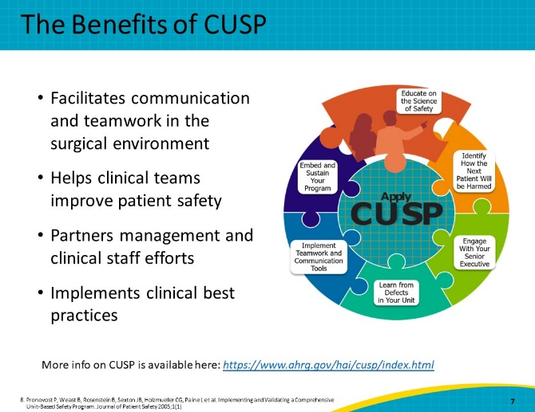
Target MRSA and Surgical Site Infections  SAY:  There are four key strategies to “Target MRSA and Surgical Site Infections.” These strategies prevent MRSA and surgical site infections through decolonization of patients, preoperative chlorhexidine skin antisepsis, antimicrobial prophylaxis, and evidence-based infection prevention practices. | Slide 8  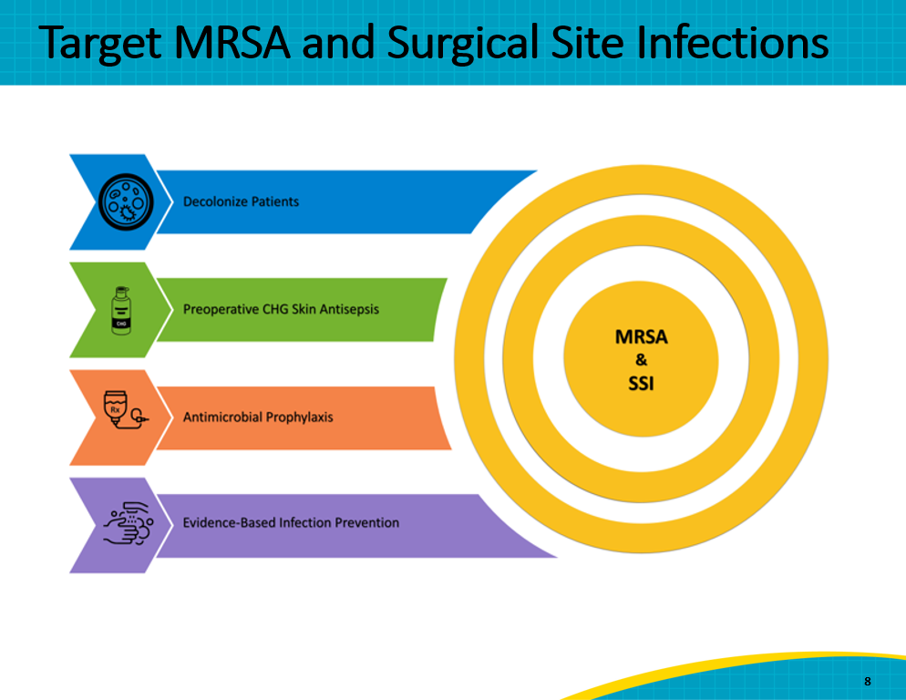
Case Example: Johns Hopkins Hospital, 2009  SAY:  We would like to briefly review a case example of how some of the interventions included in this program were implemented, using CUSP. This is real data from cardiac surgery at the Johns Hopkins Hospital. As you can see, between 2005 and 2009 there was a decrease in the SSI rate from cardiac artery bypass graft (CABG) surgery. However still by 2009 the SSI rate was still above the national average, as indicated by the dashed red line. | Slide 9  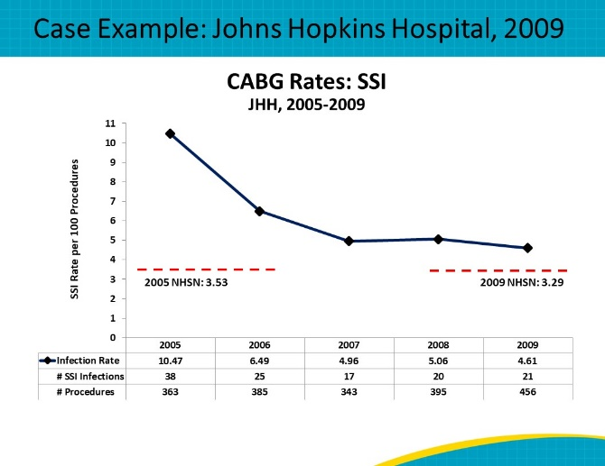
Case Example: JHH  SAY:  To address the ongoing elevated rates of SSI, in 2009 Johns Hopkins decided to tackle this problem by adopting the CUSP framework. They put together a cardiovascular surgery CUSP team. This team started with a small group, including diverse members from the surgical team. This CUSP team began meeting monthly to address the SSI problem. As time went on, more members joined as needs and stakeholders changed. The team is now broad and diverse, including perspectives from all relevant roles.  The team developed a bundle of interventions which eventually included preoperative S. aureus screenings, CHG bathing, and skin and nasal decolonization. Guidelines for antimicrobial prophylaxis and contact isolation precautions were also instituted. | Slide 10  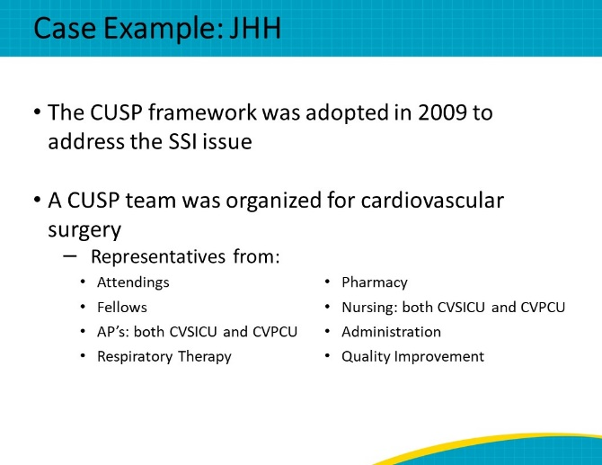
Case Example: JHH  SAY:  So how did things turn out? This graph compares the rates of CABG SSI overall and SSI due to S. aureus before and after the intervention. As you can see, there was a 40% decrease in SSI rates, and a 65% decrease in S. aureus SSIs after the interventions were implemented utilizing the CUSP framework. | Slide 11  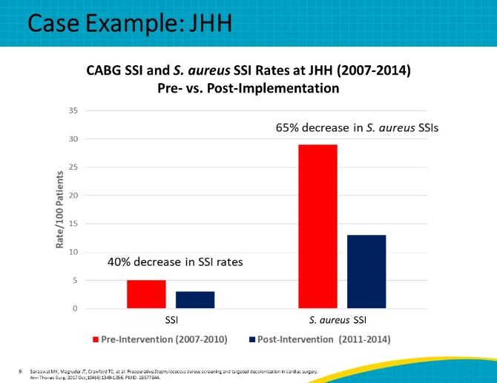
Case Example: JHH  SAY:  These implementations adapting the CUSP framework were rolled out over 5 months between 2009 and 2010. This graph shows CABG SSI rates, which dropped significantly in 2010. This decrease was sustained into 2011.  Successful implementation of these interventions was augmented by the multidisciplinary effort across surgery, nursing, pharmacy, infection prevention, anesthesiology, and administration. The challenges faced were not just the technical aspects of the interventions, but also the adaptive and cultural challenges of coordinating all these groups.  Addressing both was fundamental to ensuring outcomes could be achieved and sustained.  In this case, changes were achieved quickly. The speed of change is not the same at all hospitals. Johns Hopkins Hospital had already adopted CUSP in many of the units at this time. Administration was already ready to assist teams in implementing changes in practice.  This 18-month program is specifically designed to help you reach your goals in lowering MRSA and SSI rates in your hospital and give you the time to do it in your hospital. Over the course of this project, we hope our team’s experiences and lessons learned will help you support you in your implementation efforts. | Slide 12  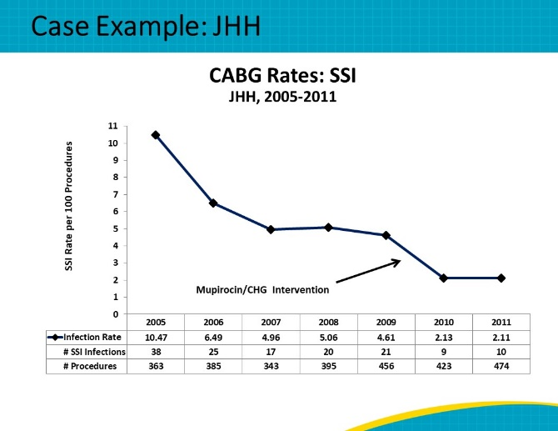
AHRQ Safety Program Details  SAY:  We have seen the success that one program can have by implementing both evidence-based and cultural change, and we hope you and your surgical program will join us in efforts to make these changes at your own institutions.  The AHRQ Safety Program for MRSA and SSI Prevention is a free 18-month program that will run from January 2023 to June 2024. The deadline for enrollment is January 15th, 2023. High-risk adult inpatient surgical services are eligible and encouraged to participate in the program. Participation in the program is free.  The surgical services that are eligible to participate are:  - Neurosurgical  - Orthopedic  - Cardiac  Within these specialties, the program will focus on the following procedures:  For Neurosurgical services:  - Spinal fusion  For Orthopedic services:  - Hip joint replacement  - Knee joint replacement  - Spinal fusion  For Cardiac services:  - Cardiac valve replacement  - Coronary artery bypass graft  - Any cardiac surgeries that involve a median sternotomy  Each participating service will form a multidisciplinary team, including leadership and frontline staff, to participate and lead the team-based intervention for the program. Program content is designed to be applicable to all of these high-risk surgical specialties.  We anticipate that participating site leads will need to spend a minimum of 3 hours per month focusing on the AHRQ Safety Program for MRSA and SSI Prevention for the program to be successful.  Continuing medical education (CMEs) and continuing education unit (CEU) credits are available for participating physician and nursing personnel. To earn these credits, participants must attend live webinars, review recorded project webinars, or review the slides and script for the webinars. Participants requesting these credits will be directed to a separate website to answer a few content-related questions.  Please note that the Johns Hopkins Medicine institutional review board (IRB) reviewed the project and determined that it is not human subjects research. Individual sites are therefore not expected to obtain local IRB review unless required to do so by their home institution. | Slide 13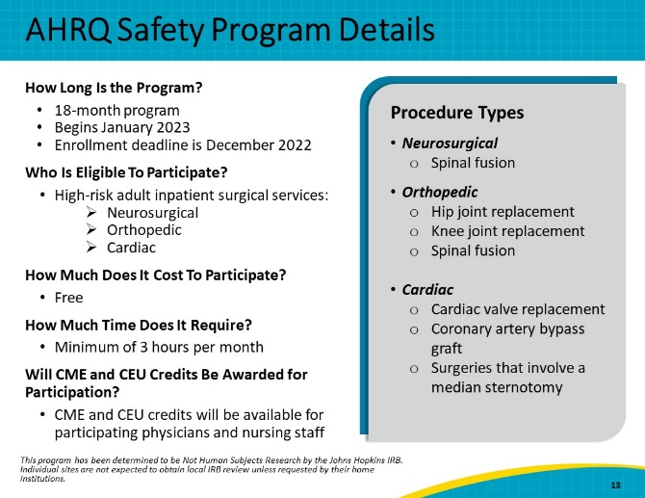
AHRQ Safety Program Timeline  SAY:  Between November and December 2022, participating services will assemble a multidisciplinary CUSP team within their service and ensure all members of the team have the opportunity to access the Safety Program website. This team will include a team leader, such as a surgeon or nursing leader, and another clinical staff member, such as an infection preventionist, to oversee the work in addition to the other front-line, multidisciplinary CUSP team members.  Participating services will be asked to sign a letter of commitment prior to participation. Between January 2023 and July 2024, enrolled services will participate in educational programs (including an orientation webinar and monthly to twice monthly educational webinars), meet regularly with their CUSP team, implement evidence-based interventions, and review and submit team-level data to the program, on a monthly or quarterly basis, in accordance with the schedule on the next slide. Participating services will receive support via Implementation Advisers (IAs), who will work directly with them, meeting at least once a month.  By May 2023, participating services will be asked to submit their baseline data, covering the 12 months preceding the start of the cohort (January 2022 to December 2022, organized monthly). May 2023 will also be the date of the first quarterly submission of clinical data. | Slide 14  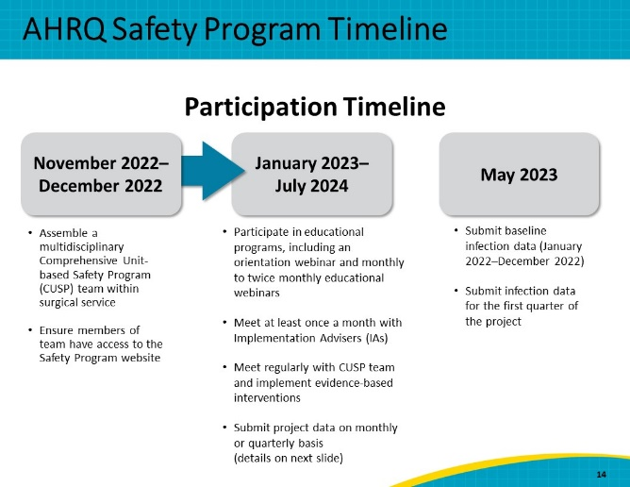
Data Collection - Hip & Knee Replacement, Spinal Fusion  SAY:  During the project, participating surgical services will be asked to submit implementation and clinical outcomes data, which vary depending on the surgery type. On this slide are the data requested for hip and knee replacements and spinal fusions. Once at the beginning and again at the end, teams will be asked to complete a gap analysis and the Hospital Survey on Patient Safety Culture (HSOPS), in order to compare infrastructure and culture before and after the program. Teams will also be asked to complete the monthly Team Checkup Tool, a brief implementation assessment to be completed by the Team Lead.  Clinical outcomes service-level data will be the number of SSI events and S. aureus SSI events (if available), to be reported quarterly, organized by month. If your hospital submits data to NHSN for these surgeries, the hospital has the option of conferring rights to allow automatic extraction of these data elements from the National Healthcare Safety Network (NHSN). If your hospital does not submit these data to NHSN, or chooses not to confer rights to NHSN, hospitals can choose to manually submit these data to the AHRQ Safety Program. | Slide 15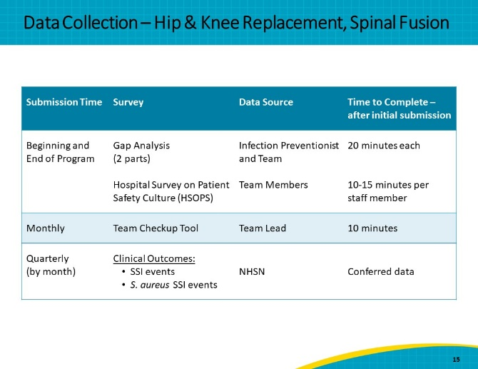
Data Collection – Cardiac Surgery  SAY:  This slide shows the data requested for cardiac surgery, which includes surgeries with a sternotomy, such as CABG, which differs in the clinical outcomes. The primary data source for these outcomes are as defined by the Society for Thoracic Surgeons (STS) National Database. Here we are asking for SSI events overall and the number of hospital readmissions for reason of infection. Clear instructions and assistance will be provided on how to reuse the data submitted to STS for submission to our program.  If your cardiac surgery service also reports SSI data to the National Healthcare Safety Network (NHSN), we will ask you to submit data on SSI events and causative organisms, related to coronary artery bypass surgery. These data can be automatically routed to the program by conferring NHSN data rights.  For all data elements, our program provides assistance to simplify the data process, including Implementation Advisers who will work individually with each site. Teams can still participate while the data collection process is being set up. | Slide 16  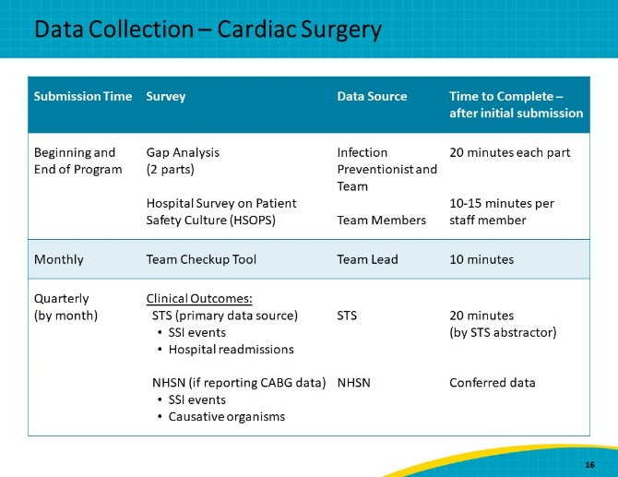
Benefits of Participating  SAY:  There are many benefits to participating in the AHRQ Safety Program. Participants will have access to experts in infection prevention and CUSP. These experts will coach the teams and help them troubleshoot issues as they set up and maintain an SSI and MRSA prevention program in the participating services. Support will also be provided for building capacity and infrastructure for data collection, reporting, analysis, and feedback. This will help you gain a detailed picture of your MRSA and SSI prevention performance and the effectiveness of interventions. You will also have close access to implementation advisers who have proven themselves to be effective QI coaches and the opportunity to participate in monthly office hours and peer-to-peer learning with other participating facilities to assist cross-learning from shared experiences.  Interactive webinars will be held one to two times per month, covering both adaptive and technical approaches to various aspects of MRSA and SSI prevention. These webinars will be 60 minutes in length, with time for presentation of educational information, as well as for questions and answers. They will be recorded and available on the project website for 24/7 access following each live webinar. The webinar reference materials, slides, and facilitator guides will also be available on the website. In addition to the webinars, you will also have access to a variety of tools on the project website to assist with developing and sustaining protocols and quality improvement for participating services. These tools include but are not limited to posters, one-page summary sheets, and videos, as well as educational materials for patients and families. | Slide 17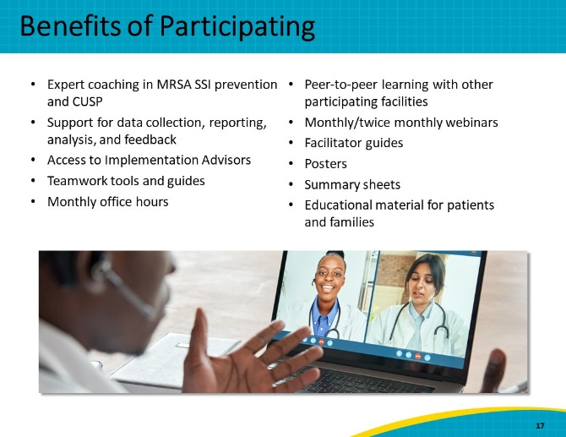
Anticipated Outcomes of Participation  SAY:  The anticipated outcomes of participation include:  - Reduced MRSA SSIs  - Reduced overall SSIs  - Improved team-based infection prevention practices, including decolonization, CHG bathing, and antimicrobial prophylaxis  - Enhanced communication and teamwork regarding prevention of MRSA and surgical site infections and improved teamwork and patient safety culture | Slide 18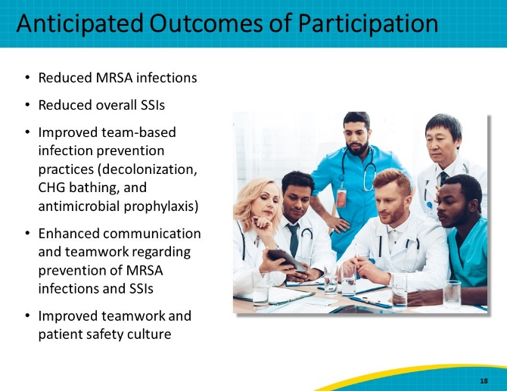
Thank You  SAY:  Thank you for your time today and for attending this webinar on the AHRQ Safety Program for MRSA and SSI Prevention. As you know, SSIs and MRSA infections pose serious threats to patient safety, causing thousands of infections and deaths each year in the United States. The AHRQ Safety Program for MRSA and SSI Prevention can help you and your surgical services redouble your efforts to combat these threats.  We understand that in the current climate, committing to such a program may be a difficult choice. However, during the COVID-19 pandemic, MRSA rates have risen significantly nationwide. If you choose to join our program, we will ensure you have access to tools that will assist and support you and your teams in your implementation efforts to prevent MRSA and SSIs. We will also be here for you should there be another COVID-19 surge, and we will help you overcome any barriers you may encounter.  We hope that this presentation has convinced you of the value of this program and the importance of MRSA and SSI prevention for patient safety. We look forward to working with you on improving the delivery of high-quality care for patients across the United States.  To learn more and enroll, visit: https://safetyprogram4mrsaprevention.org  or email MRSAPrevention@norc.org.  The deadline to enroll is January 15th, 2023.  Thank you. I will be happy to answer any questions you might have at this time. | Slide 19  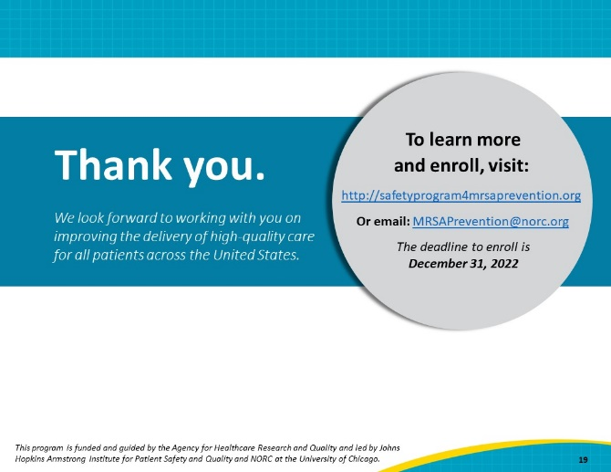
References | Slide 20